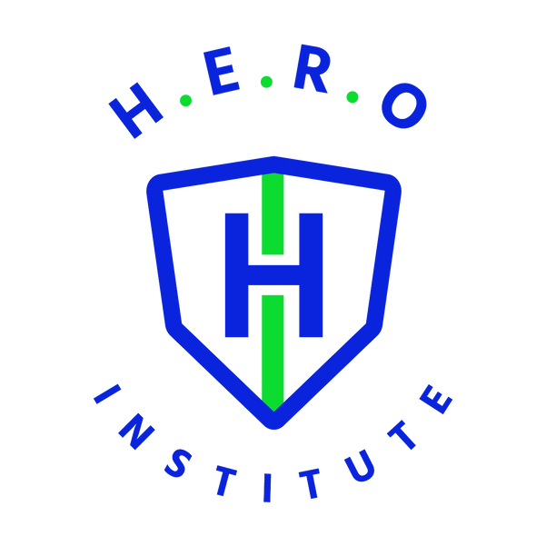

6130 Hotel Street, Austell, GA 30106
770-726-3577
www.heroinstitute.com Catalog Volume IV School Year 2026-2027 Published June 1st, 2026
TABLE OF CONTENTS
Institute History 3
Approvals 4
Description of Space, Facilities & Equipment 4-5
Learning Resources Management 5
Board of Trustees 6
Administration 6
Faculty and Instructors 6
Courses Offered 7
Course Description & Outline 8-41
Fees, Tuition & Special Charges 41-42
Holidays 43
Enrollment Periods 43
Course Enrollment Dates 43-44
Scheduled Vacation Periods 44
Office Hours 44
Emergencies and Inclement Weather 44
Credit for Previous Education Training or Experience 45
Cancellation & Refund Policy 45-46
Grading Policy 46-47
Certificate Awarded 47
Academic Probation/Termination 48
Incompletes and Withdrawals 48
Remedial Work and Repeat Courses 49
Attendance Policy 49-50
Make-up Work 50
Student Conduct Policy 50-51
Sexual Harassment 51-52
Requirements for Graduation 52
Transcript Requests 52
Transfer of Credit Hours 52
Student Complaints/ Grievance Procedures 52-53
Readmission Policy 53
Career Services 53-54
Criminal Backgrounds 54
Student Disclosure Form 55
Laboratory Procedures Agreement 56
Student Consent & Waiver 57

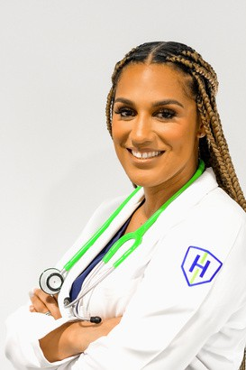
H.E.R.O Institute History

Welcome to H.E.R.O Institute where Healthcare Education is Reimagined Online! Our founder and School Administrator Victoria Randle created our programs with you and your busy life in mind. As healthcare continues to evolve, so should the way we train our healthcare professionals. We have created engaging online experiences paired with in person hands-on training by professionals in the field.

Victoria got her start as a Patient Care Technician/ CNA and it changed her life. Three degrees later, she is a Nurse Practitioner and owes her success in the medical field to becoming a CNA. In Victoria’s 17 years of healthcare experience, she has worked in long term acute care, assisted living, burn ICU, urgent care and as a CNA instructor. She has a dual passion for patients and students alike.
Touching lives and making an economic impact in the community is her focus.

Victoria created H.E.R.O Institute to provide superior education and endless opportunities to others wanting to enter the healthcare field. H.E.R.O Institute is the premier educational institute in the nation that will change lives for generations to come. We hope you choose to be a part of this impact!

Our Mission:
The mission of H.E.R.O Institute is to provide engaging healthcare education in a flexible fashion to meet the demands of today and create quality caregivers for tomorrow. Our advanced curriculum ensure students are prepared and confident for their future healthcare careers.

Our Vision:
H.E.R.O Institute envision a world where students have the opportunity to engage in flexible healthcare education opportunities so they can obtain career paths that can change the trajectory of their future for the good.
H.E.R.O Institute is owned and operated by
Victoria Randle MSN, NP-C.

APPROVALS
H.E.R.O Institute is authorized to operate by the Georgia Nonpublic Post-Secondary Education Commission.

DESCRIPTION OF SPACE, FACILITIES AND EQUIPMENT
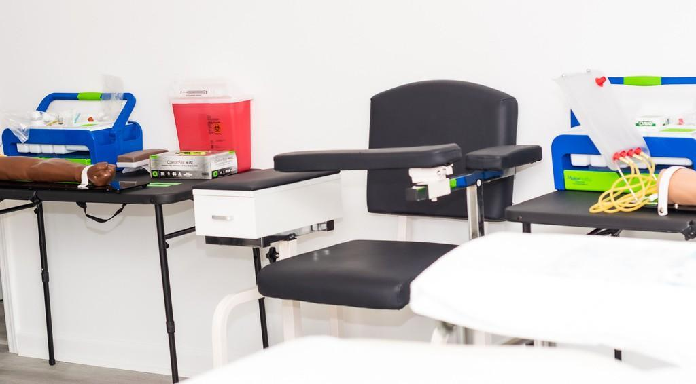
H.E.R.O Institute is located at 6130 Hotel Street, Austell, GA. The 1400 sqft space is filled with state-of-the-art educational equipment for students to gain the best real-life experience from our program. Although the majority of our classes are online, we do offer a classroom for debriefing and onsite instruction when indicated. The school has three lab stations for learning. There is a set up like a real resident’s room to help simulate real life experience for student learning in the Patient Care Technician Program. A hospital style bed and manikin are provided for student learning. Other items for learning include but are not limited to: bath basins, dentures, toothbrushes, walkers, toothbrushes, emesis basins, and bedside commode.

There is another lab area for the Phlebotomy Technician practice in which artificial arms of multiple ethnicities are along with needles and lancets for blood sticks and draws. There are lab chairs to ensure comfort for blood draws.
Lastly there is a mock clinic/ doctor’s office area for patient exams. Here is where Medical Assistant students will engage in their learning experience. The clinical consists of an exam table, otoscopes, vital signs machines and medications for administration.

Attention students in hybrid learning courses:

Students who enter the hybrid option must have access to a computer, internet, and should install Google Chrome browser on their computer as our LMS, Canvas is best suited for use on this browser. A tablet or iPad is not well suited for online learning due to its limitations and students cannot use these devices. Students must also have access to Microsoft Word or Google Word, and a PDF reader so they may download documents from the online course. Lastly students must have a computer equipped with a webcam with at least 1040p or obtain a webcam and connect it to the computer as students must be on screen during a live lecture.

LEARNING RESOURCES MANAGEMENT
H.E.R.O Institute does provide a resource library in the lab areas with reference books to help enhance student learning as it relates to the curriculum. Reference materials are allowed for use on premises only and students may be allowed to check books out for use after hours. All books that have been checked out must be returned in 24 hours so that other students may use the reference materials as well. The courses offered by H.E.R.O Institute do not require the use of advanced learning resource systems such as Nexis Lexis and other online reference libraries. Each program instructor is responsible for the management of the student library and will replace and update books as needed. H.E.R.O Institute’s staff are also trained and qualified to assist students in utilizing the library resources and will provide oversight to students with use of these resources.

BOARD OF TRUSTEES
Hani Mahmoud CPA
Victoria Randle, MSN, NP-C Owner/ Administrator Dayna Cook-Thomas Attorney

ADMINISTRATION
Victoria Randle MSN, NP-C Owner/ Administrator Admin@heroinstitute.com
770-726-3577

FACULTY AND INSTRUCTORS
PCT, Phlebotomy, Medical Assistant, Adjunct Instructor: Victoria Randle MSN, NP-C Email: Admin@heroinstitute.com
Number: 678-310-6168
Office Hours: Monday- Wednesday 9:00am- 2:00pm College: Southern Indiana University

Phlebotomy Instructor: Courtney Jackson CPT
Email:courtney@heroinstitue.com
Number: 708-829-9177
Office Hours: Monday – Wednesday 4:00-5:00pm College: H.E.R.O Institute

Patient Care Technician/ Medical Assistant Instructor: Kimberly Smith MSN, NP-C Email: Kim@heroinstitute.com
Number: 912-604-6225
Office Hours: Thursday 4:00pm-5:00pm College: Georgia State University

Medical Assistant/ Phlebotomy Instructor: Jane Esenwein BS, MPS-HS, MM, RN, CHPN
Email: Jane@heroinstitue.com Number: 678-836-4605
Office Hours: Monday – Wednesday 3:00-4:00pm College: University of State of New York

COURSES OFFERED:

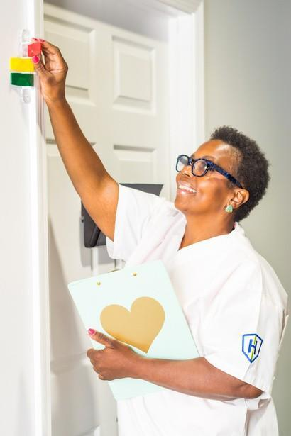
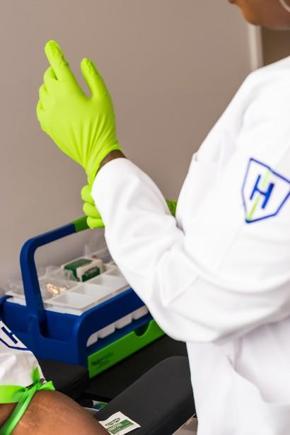
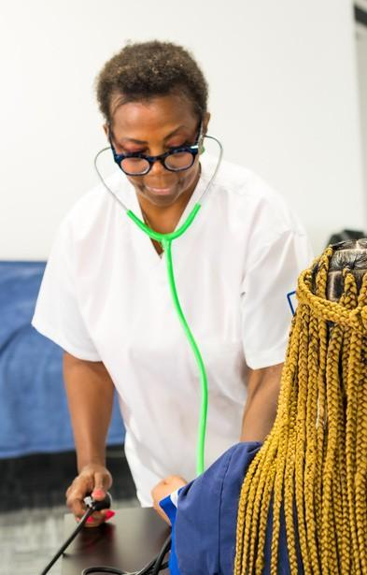

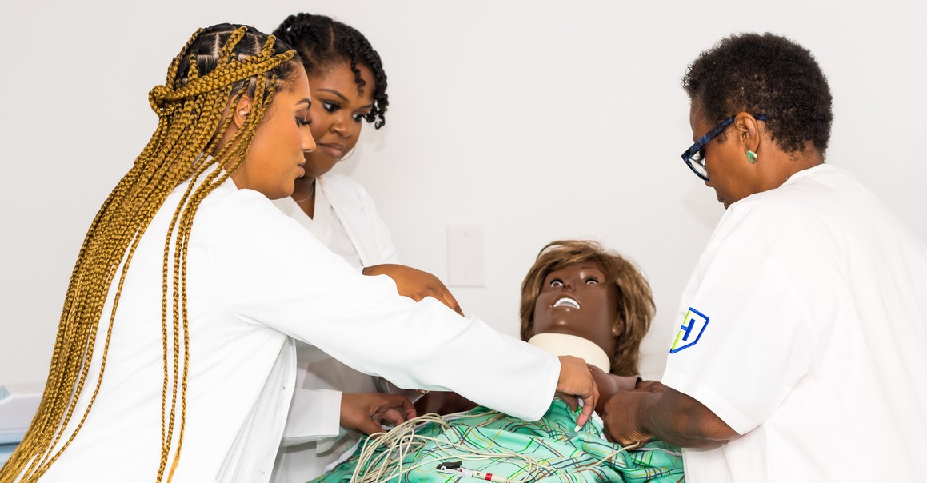
Medical Assistant Program

Phlebotomy Technician Program
Patient Care Technician Program
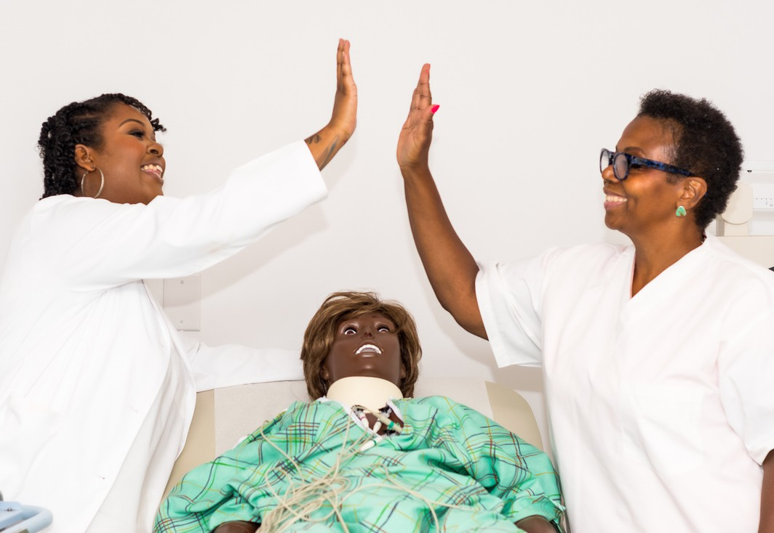


COURSE DESCRIPTIONS AND OUTLINE


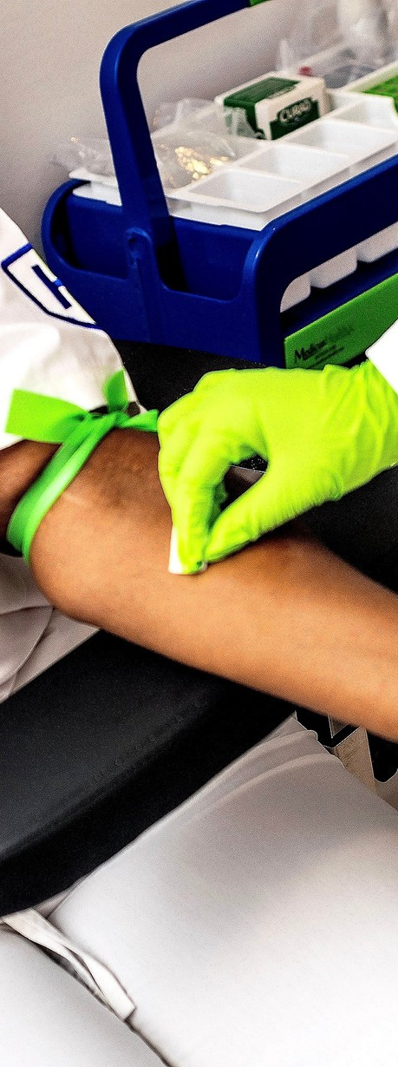
Phlebotomy Technician Program

This program is designed to provide students with the knowledge and skills that are required to become a Phlebotomy Technician. The Phlebotomy Technician program educates students to collect, process and properly transport laboratory specimens, correctly lab specimens, identify pre-analytical errors, and clinical procedures under the supervision of a Provider. Phlebotomy Technicians typically work in conjunction with clinical laboratory personnel and other healthcare providers in clinics or other healthcare facilities.
They also may work within the hospital, private physician offices, etc. Through classroom work and skills lab training, students learn to collect blood specimens by venipuncture, finger sticks, heel sticks, perform vision and hearing screening, etc. Students do not need to leave the school and attend any other location for this portion of the course. The end of the course includes clinical practicum which will occur in the lab during normal class hours. Upon successful completion, students are prepared to sit for the NHA National Certification Exam. This course is 120 hours of instruction which include 6 modules of learning (PH 100-PH 105).Please see the modules below. Upon completion, all students will be given the opportunity to sit for the Certification Exam with National Healthcareer Association (NHA). Certification is not required for employment; however, it is highly recommended.

A certificate of completion is provided at the end of the course. Upon successful completion of the Phlebotomy Technician program, students will be able to obtain jobs as a Certified Phlebotomy Technician in the following areas:

- Hospitals
- Private practices and clinics
- American Red Cross
- Nursing homes
- VA clinics/hospitals
- Urgent care or emergency clinics
- Mobile phlebotomy
- Paramedical examiners
- Health fairs


Course Hours:

120 Clock hours with the following breakdown. 80 hours of in person theory, 40 hours of lab.
Day Class: 9:00am-4:00pm. M-Th (20 days/ 5 weeks) Evening Class: 5:00pm-9:00pm M-Th (30 days/ 7.5 weeks)


Performance Objectives:
- Prepare students for success in a healthcare career path
leading to post-secondary programs that license healthcare
professionals.
- Uphold the honor and high principles of the profession and
accept its disciplines.
- Develop attitudes consistent with those expected of an
individual working in the health care industry and society in general.
- Demonstrate the knowledge, skills, and professionalism required by employers and patients.
- Identify common clinical procedures performed in the medical office.
- Demonstrate knowledge of the systematic examination of patients.
- Apply administrative principles in the medical office setting.
- Demonstrate knowledge of EMR, office accounting, and medical law/ethics to work in an office.
- Apply for and pass the Certification Exam through National Healthcareer Association (NHA).

Required Textbooks:
Textbook: Hartman's Complete Guide for the Phlebotomy Technician, 2nd Edition, ISBN: 978-1-60425-165-4
Workbook: Hartman's Complete Guide for the Phlebotomy Technician, 2nd Edition, ISBN: 978-1-60425-166-1

REQUIREMENTS FOR ADMISSION TO PROGRAM / COURSE:
- Must be 16 years of age or older
- GED or High School Diploma
- Pass literacy exam with 75% or higher
- Government Issued ID
- Social Security Card
- Hep B Vaccination

If you have a background concern, please let us know and different clinicals may be arranged.

Instructional Methods:
Instruction for this course will include lectures, PowerPoint presentations, case studies, videos, clinical skills, instructor demonstration, return demonstration, interactive games, and role play.

Student to Instructor Ratio 20:1

Course Outline:

PH100: Introduction to Phlebotomy Contact Hours: 16

This subject includes an introduction to the field of phlebotomy, the history and the profession. Understanding the healthcare structure and how phlebotomy fits into the structure. Understanding safety concerns surrounding the phlebotomy profession. Understanding how to maintain infection control as a phlebotomist.

PH101: Phlebotomy Basics Contact Hours: 16 hours Theory

This subject explains medical terminologies phlebotomists should be familiar with while working in the healthcare setting. Understanding human anatomy and physiology in order to engage in duties. Understanding the circulatory system, lymphatic system, and immune system as it relates to the world of phlebotomy.

PH102: Specimen Collection Contact Hours: 16 hours Theory/ 8 Hours Lab

This subject introduces students to venipuncture equipment and how to complete routine venipunctures. Also understanding how to conduct capillary collections.
Understanding pre-analytic variables to conduct blood draws and venipuncture complications that can occur in the workplace. Understanding blood collections in special populations and considerations to consider. Understanding arterial blood collections and why they are needed. Engaging in special collections and procedures/techniques for certain tests. Understanding special non-blood collection procedures such as specimen collections of sputum, stool, and urine.

PH103: Specimen Handling Contact Hours: 10 hours Theory/ 6 Hours Lab

This subject introduces students to how to handle specimens during transport processing and any other special considerations related to specimens.
Understanding point of care testing, when testing should occur, the importance of POC testing and consideration when conducting POC tests.

PH104: Professional Issues Contact Hours: 8 Hours Theory This subject discusses quality matters surrounding phlebotomy such as
procedure manual quality controls delta checks preanalytical variables, etc. Understanding legal issues surrounding phlebotomy such as loss scope of practice liability malpractice and confidentiality.

PH105: Lab Practicum Contact Hours: 40 hours Lab

In this course, students will practice hands-on what they have learned in the course. Learning may occur in a lab where students get to practice venipunctures and capillary sticks to satisfy requirements needed for certification, should the student choose to sit for the national qualifying exam. Students do not need to leave the school and attend any other location for this portion of the course. Lab practicum will occur in the lab during normal class hours.


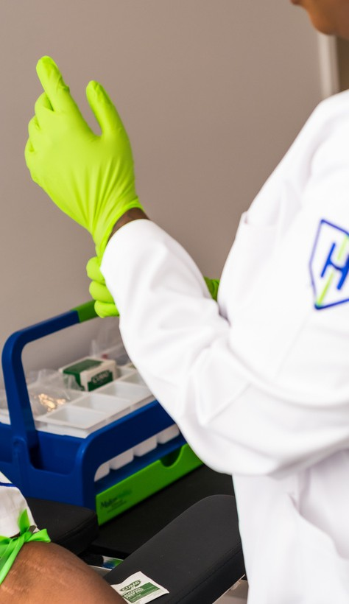


Hybrid Phlebotomy Technician Program

This course consists of online and in person instruction. This program is designed to provide students with the knowledge and skills that are required to become a Phlebotomy Technician. The Phlebotomy Technician program educates students to collect, process and properly transport laboratory specimens, correctly lab specimens, identify pre-analytical errors, and clinical procedures under the supervision of a Provider. Phlebotomy Technicians typically work in conjunction with clinical laboratory personnel and other healthcare providers in clinics or other healthcare facilities. They also may work within the hospital, private physician offices, etc. Through classroom work and skills lab training, students learn to collect blood specimens by venipuncture, finger sticks, heel sticks, perform vision and hearing screening, etc. Students do not need to leave the school and attend any other location for this portion of the course. The end of the course includes clinical practicum which will occur in the lab during normal class hours. Upon successful completion, students are prepared to sit for the NHA National Certification Exam. This course is 120 hours of instruction which include 6 modules of learning (HPH 100-HPH 105). Please see the modules below. Upon completion, all students will be given the opportunity to sit for the Certification Exam with National Healthcareer Association (NHA). Certification is not required for employment; however it is highly recommended.

Students who elect for the hybrid course option can expect to engage in online learning for the classroom/ theory portion of the course. Online learning will be a live lecture conducted via Zoom. Students will conduct live assessments through gamification while in lecture. Students will also engage in quiz questions via online forms that are auto submitted to their instructor. These items along with course syllabus and presentations will be in the students learning management system.
All tests will be conducted in person prior to the student’s lab experiences.

A certificate of completion is provided at the end of the course. Upon successful completion of the Phlebotomy Technician program, students will be able to obtain jobs as a Certified Phlebotomy Technician in the following areas:

- Hospitals
- Private practices and clinics
- American Red Cross
- Nursing homes
- VA clinics/hospitals
- Urgent care or emergency clinics
- Mobile phlebotomy
- Paramedical examiners
- Health fairs

Course Hours:

120 Clock hours with the following breakdown. 80 hours of online theory, 40 hours of in person lab.
Day Class: 9:00am-4:00pm. M-Th (20 days/ 5 weeks) Evening Class: 5:00pm-9:00pm M-Th (30 days/ 7.5 weeks)


Performance Objectives:
- Prepare students for success in a healthcare career path
leading to post-secondary programs that license healthcare
professionals.
- Uphold the honor and high principles of the profession and
accept its disciplines.
- Develop attitudes consistent with those expected of an
individual working in the health care industry and society in general.
- Demonstrate the knowledge, skills, and professionalism required by employers and patients.
- Identify common clinical procedures performed in the medical office.
- Demonstrate knowledge of the systematic examination of patients.
- Apply administrative principles in the medical office setting.
- Demonstrate knowledge of EMR, office accounting, and medical law/ethics to work in an office.
- Apply for and pass the Certification Exam through National Healthcareer Association (NHA).

Required Textbooks:
Textbook: Hartman's Complete Guide for the Phlebotomy Technician, 2nd Edition, ISBN: 978-1-60425-165-4
Workbook: Hartman's Complete Guide for the Phlebotomy Technician, 2nd Edition, ISBN: 978-1-60425-166-1

REQUIREMENTS FOR ADMISSION TO PROGRAM / COURSE:

- Must be 16 years of age or older
- GED or High School Diploma
- Pass literacy exam with 75% or higher
- Government Issued ID
- Social Security Card
- Hep B Vaccination Proof

Instructional Methods:
Instruction for this course will include lectures, PowerPoint presentations, case studies, videos, clinical skills, instructor demonstration, return demonstration, interactive games, and role play.

Student to Instructor Ratio 20:1

Course Outline:
HPH100: Introduction to Phlebotomy Contact Hours: 16 hrs Theory

This subject includes an introduction to the field of phlebotomy, the history and the profession. Understanding the healthcare structure and how phlebotomy fits into the structure. Understanding safety concerns surrounding the phlebotomy profession. Understanding how to maintain infection control as a phlebotomist.

HPH101: Phlebotomy Basics Contact Hours: 16 hrs Theory

This subject explains medical terminology phlebotomists should be familiar with while working in the healthcare setting. Understanding human anatomy and physiology in order to engage in duties. Understanding the circulatory system, lymphatic system, and immune system as it relates to the world of phlebotomy.HPH102: Specimen Collection Contact Hours: 16 hrs Theory, 8 hrs Lab

This subject introduces students to venipuncture equipment and how to complete routine venipunctures. Also understanding how to conduct capillary collections.
Understanding pre-analytic variables to conduct blood draws and venipuncture complications that can occur in the workplace. Understanding blood collections in special populations and considerations to consider. Understanding arterial blood collections and why they are needed. Engaging in special collections and procedures/techniques for certain tests. Understanding special non-blood collection procedures such as specimen collections of sputum, stool, and urine.

HPH103: Specimen Handling Contact Hours: 10 hrs Theory, 6 hrs Lab

This subject introduces students to how to handle specimens during transport processing and any other special considerations related to specimens.
Understanding point of care testing, when testing should occur, the importance of POC testing and consideration when conducting POC tests.

HPH104: Professional Issues Contact Hours: 8 hrs Theory

This subject discusses quality matters surrounding phlebotomy such as procedure manual, quality controls, delta checks, preanalytical variables, and etc.
Understanding legal issues surrounding phlebotomy such as scope of practice liability, malpractice, and confidentiality.

HPH105: Clinical Practicum Contact Hours: 40 hrs Practicum In this course, students will practice hands on what they have learned in the
course. Learning will occur in the lab where students get to practice venipunctures and capillary sticks to satisfy requirements needed for certification, should the student choose to sit for the national qualifying exam. Students do not need to leave the school and attend any other location for this portion of the course.
Clinical practice will occur in the lab during normal class hours.
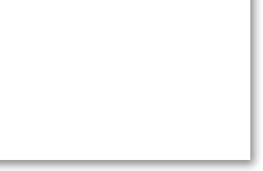
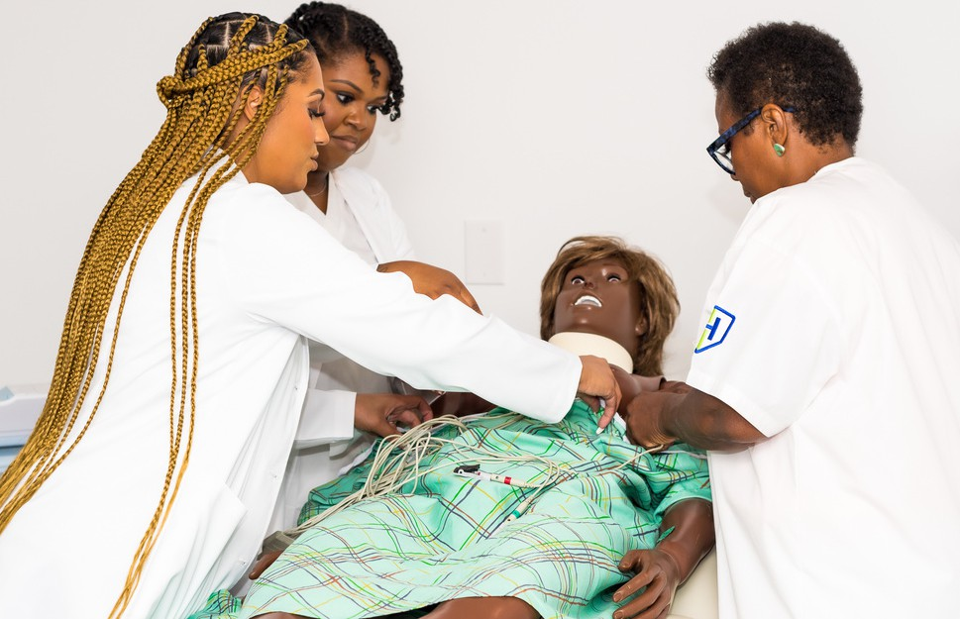

Patient Care Technician Program

The patient care technician is an advanced entry level healthcare career for students who prefer to engage in direct patient care. The course is designed to teach students how to communicate with patients effectively, recognize medical emergencies, provide hands-on daily care needs while respecting the patient’s rights, the skill of obtaining EKG and blood draw. This course is taught in English only. The course consists of theory, lab and clinical experiences. Prerequisites for this course are satisfied during the enrollment process. Students will learn how to perform vital signs, observing/ reporting, and follow infection prevention measures. After successful completion of this program, student will receive a certificate of completion and will be eligible to sit for the NHA exam for the following certifications: Certified Patient Care Technician/ Assistant (CPTC/A), Certified Echocardiogram Technician (CET), Certified Phlebotomy Technician (CPT). Students may not be required to be certified in order as a PCT, so for employment based on the employer.

Graduates of this program may find entry-level employment as a patient care technician working in hospitals, home health, hospice facilities and clinics just to name a few.
Course Hours:
300 Clock hours with the following breakdown: 180 hours in class and 120 hours of lab experience.
Day Class: 9:00am-4:00pm M-Th. (60 Days or 12.5 weeks) Evening Class: 5:00pm-9:00pm M-Th. (75 Days or 19 weeks)


Program Objectives:
- Students will be prepared to care for patients in an array of clinical atmospheres included but not limited to, hospital setting, clinic, home health, or rehab facilities.
- Student will be able to sit for the national certification exam with the NHA for any of the following certification:
Certified Patient Care Technician/ Assistant (CPTC/A), Certified Echocardiogram Technician (CET), Certified Phlebotomy Technician (CPT).
- Students will be able to identify and observe legal and ethical behavior.
- Students will be engaged in proper infection control procedures.
- Students will be able to demonstrate basic care skills, patient care procedures, EKG, and blood draw abilities.
- Students will be able to identify medical emergencies and how to respond effectively.
- This program will graduate 90% of its enrolled students.
- This program will have 80% of its graduates obtain a certification after completion of the course.
- Eight percent of graduates who go on to obtain certification will obtain gainful employment in the chosen career field.

REQUIRED TEXTBOOK:
Fundamental Concepts and Skills for the Patient Care Technician, 2018, Mosby, Kimberly Townsend, PhD, RN, WHNP-BC, CNE, ISBN: 9780323430135

Workbook for Fundamental Concepts and Skills for the Patient Care Technician, 2018, Mosby, Kimberly Townsend, PhD, RNH, WHNP-BC, CNE, ISBN: 9780323445719

PREREQUISITE COURSES & OTHER REQUIREMENTS FOR ADMISSION TO PROGRAM / COURSE:
- Must be 16 years of age or older
- High School Diploma or GED
- Pass literacy exam with 75% or higher
- Government issued ID
- Social Security card
- Negative PPD Test
- Proof of Hep B Vaccine

Instructional Methods:
Instruction for this course will include lectures, PowerPoint presentations, case studies, videos, clinical skills, instructor demonstration, return demonstration, interactive games, and role play.

Student to Instructor Ratio: 20:1

Course Outline:

NA100: Introduction to Nurse Assistant Contact Hours: 5 hours theory

This subject introduces students to the role of the nurse aide/ patient care technician and their scope of practice.

NA101: Anatomy & Physiology Contact Hours: 10 hours theory

This subject includes human anatomy and physiology including all body systems. Students will learn and understand the integumentary system, musculoskeletal system, cardiovascular system etc.

NA102: Infection Prevention Contact Hours: 10 hours theory

This subject introduces students to the basic components of infection prevention as well as the chain of infection. Understanding different types of micro- organisms and preventing the spread of microorganisms is essential to the care of people.

NA103: Basic Care Skills Contact Hours: 20 hours theory

This subject introduces students to the concepts of providing basic needs services to those in need. This includes bed making, vital signs, food preparation etc.

NA104: Personal Care Skills Contact Hours: 20 hours theory

This subject introduces students to the concepts of providing basic ADL service (activities of daily living). Students will be able to assist those in need with basic care skills such as bathing, toileting or grooming.
NA105: Mental Health & Social Needs Contact Hours: 5 hours theory

This subject introduces students to the psychological needs of patients. Students will learn about depression and anxiety, schizophrenia, dementia and other mental illnesses patients may experience.

NA106: Rehabilitation Contact Hours: 10 hours theory

This subject introduces students to rehabilitation care. Students will learn how to assist individuals who may not have full function of their limbs. Encouraging patients to engage in self-care and strengthening exercises is discussed.

NA107: Nurse Aide Lab Practicum Contact Hours: 40 hours lab

This course allows students to practice the skills and concepts they have learned in class on manikins and real people. Concepts of oral care, transferring, bathing, and grooming our practices.

PH100: Introduction to Phlebotomy Contact Hours: 16 hours Theory

This subject includes an introduction to the field of phlebotomy, the history and the profession. Understanding the healthcare structure and how phlebotomy fits into the structure.
Understanding safety concerns surrounding the phlebotomy profession. Understanding how to maintain infection control as a phlebotomist.

PH101: Phlebotomy Basics Contact Hours: 16 hours Theory

This subject explains medical terminologies phlebotomists should be familiar with while working in the healthcare setting. Understanding human anatomy and physiology in order to engage in duties. Understanding the circulatory system, lymphatic system, and immune system as it relates to the world of phlebotomy.

PH102: Specimen Collection Contact Hours: 16 hours Theory/ 7 Hours Lab

This subject introduces students to venipuncture equipment and how to complete routine venipunctures. Also understanding how to conduct capillary collections.
Understanding pre-analytic variables to conduct blood draws and venipuncture complications that can occur in the workplace. Understanding blood collections in special populations and considerations to consider. Understanding arterial blood collections and why they are needed. Engaging in special collections and procedures/techniques for certain tests.
Understanding special non-blood collection procedures such as specimen collections of sputum, stool, and urine.

PH103: Specimen Handling Contact Hours: 10 hours Theory/ 7 Hours Lab

This subject introduces students to how to handle specimens during transport processing and any other special considerations related to specimens.
Understanding point of care testing, when testing should occur, the importance of POC testing and consideration when conducting POC tests.

PH104: Professional Issues Contact Hours: 6 hours Theory

This subject discusses quality matters surrounding phlebotomy such as procedure manual quality controls delta checks preanalytical variables etc. Understanding legal issues surrounding phlebotomy such as loss scope of practice liability malpractice and confidentiality.

PH105: Lab Practicum Contact Hours: 26 hours Lab
In this course, students will practice hands on what they have learned in the course. Learning may occur in lab where students get to practice venipunctures and capillary sticks to satisfy requirements needed for certification, should the student choose to sit for the national qualifying exam. Students do not need to leave the school and attend any other location for this portion of the course. Clinical practice will occur in the lab during normal class hours.

EC100: The Role of the EKG Technician Contact Hours: 8 hours theory

This subject introduces students to the role of the EKG technician and what to expect as an EKG technician. Safety and emergencies are discussed as well.

EC101: Cardiovascular Diseases and Disorders Contact Hours: 10 hours theory

This subject introduces students to the different cardiovascular diseases and disorders they may encounter or see noted on rhythm strips. Understanding the why behind the procedure is essential for the EKG technician to assist physicians and other practitioners.

EC102: EKG Technology and Procedures Contact Hours: 8 hours theory

This subject introduces students to the different procedures the EKG tech mission may engage in. This course also explains the EKG/ECG technology and how it works.
EC103: EKG Tracing & Rhythm Interpretation Contact Hours: 10 hours theory

In this subject he introduces students to the world of heart tracing. Students will learn how to apply leads for heart tracing, how to read and interpret rhythm strips in an effort to alert practitioners of any emergency issues noted.

EC 104: EKG Lab Practicum Contact Hours: 40 hours Lab

This subject allows students to practice what they have learned in the prior courses in real life with real people. Students will actually engage in an EKG heart tracing and rhythm strip reading. Students will be required to report findings and note any emergencies.


Hybrid Patient Care Technician Program

The patient care technician is an advanced entry level healthcare career for students who prefer to engage in direct patient care. This course is conducted online and in person. The course is designed to teach students how to communicate with patients effectively, recognize medical emergencies, provide hands-on daily care needs while respecting the patient’s rights, the skill of obtaining EKG and blood draw. This course is taught in English only. The course consists of theory, lab and clinical experiences. Prerequisites for this course are satisfied during the enrollment process. Students will learn how to perform vital signs, observing/ reporting, and follow infection prevention measures. After successful completion of this program, student will receive a certificate of completion and will be eligible to sit for the NHA exam for the following certifications: Certified Patient Care Technician/ Assistant (CPTC/A), Certified Echocardiogram Technician (CET), Certified Phlebotomy Technician (CPT).
Students may not be required to be certified in order as a PCT, so for employment based on the employer.

Students who elect for the hybrid course option can expect to engage in online leaning for the classroom/ theory portion of the course. Online learning will be live lecture conducted via Zoom. Students will conduct live assessments through gamification while in lecture. Students will also engage in quiz questions via online forms that are auto submitted to their instructor. These items along with course syllabus and presentations will be in the students learning management system.
All tests will be conducted in person prior to the student’s lab experiences.

Graduates of this program may find entry-level employment as a patient care technician working in hospitals, home health, hospice facilities and clinics just to name a few.
Course Hours:

300 Clock hours with the following breakdown: 180 hours of online learning and 120 hours of in person lab experience in person.
Day Class: 9:00am-4:00pm M-Th. (60 days or 12.5 weeks) Evening Class: 5:00pm-9:00pm M-Th. (75 days or 19 weeks)

Program Objectives:

- Students will be prepared to care for patients in an array of clinical atmospheres included but not limited to, hospital setting, clinic, home health, or rehab facilities.
- Student will be able to sit for the national certification exam with
- the NHA for any of the following certification: Certified Patient Care Technician/ Assistant (CPTC/A), Certified Echocardiogram Technician (CET), Certified Phlebotomy Technician (CPT).
- Students will be able to identify and observe legal and ethical behavior.
- Students will be engaged in proper infection control procedures.
- Students will be able to demonstrate basic care skills, patient care procedures, EKG, and blood draw abilities.
- Students will be able to identify medical emergencies and how to respond effectively.
- This program will graduate 90% of its enrolled students.
- This program will have 80% of its graduates obtain a certification after completion of the course.
- Eight percent of graduates who go on to obtain certification will obtain gainful employment in the chosen career field.

REQUIRED TEXTBOOK:
Fundamental Concepts and Skills for the Patient Care Technician, 2018, Mosby, Kimberly Townsend, PhD, RN, WHNP-BC, CNE, ISBN: 9780323430135

Workbook for Fundamental Concepts and Skills for the Patient Care Technician, 2018, Mosby, Kimberly Townsend, PhD, RNH, WHNP-BC, CNE, ISBN: 9780323445719

PREREQUISITE COURSES & OTHER REQUIREMENTS FOR ADMISSION TO PROGRAM / COURSE:

- Must be 16 years of age or older
- High School Diploma or GED
- Pass literacy exam with 75% or higher
- Government issued ID
- Social Security card
- Negative PPD Test
- Proof of Hep B Vaccine

Instructional Methods:
Instruction for this course will include lectures, PowerPoint presentations, case studies, videos, clinical skills, instructor demonstration, return demonstration, interactive games, and role play.

Student to Instructor Ratio: 20:1
Course Outline:
HNA100: Introduction to Nurse Assistant Contact Hours: 5 hours theory

This subject introduces students to the role of the nurse aide/ patient care technician and their scope of practice.

HNA101: Anatomy & Physiology Contact Hours: 10 hours theory

This subject includes human anatomy and physiology including all body systems. Students will learn and understand the integumentary system, musculoskeletal system, cardiovascular system etc.

HNA102: Infection Prevention Contact Hours: 10 hours theory

This subject introduces students to the basic components of infection prevention as well as the chain of infection. Understanding different types of micro-organisms and preventing the spread of microorganisms is essential to the care of people.

HNA103: Basic Care Skills Contact Hours: 20 hours theory

This subject introduces students to the concepts of providing basic needs
services to those in need. This includes bed making, vital signs, food preparation
etc.

HNA104: Personal Care Skills Contact Hours: 20 hours theory

This subject introduces students to the concepts of providing basic ADL service (activities of daily living). Students will be able to assist those in need with basic care skills such as bathing, toileting or grooming.

HNA105: Mental Health & Social Needs Contact Hours: 5 hours theory

This subject introduces students to the psychological needs of patients. Students will learn about depression and anxiety, schizophrenia, dementia and other mental illnesses patients may experience.

HNA106: Rehabilitation Contact Hours: 10 hours theory

This subject introduces students to rehabilitation care. Students will learn how to assist individuals who may not have full function of their limbs. Encouraging patients to engage in self-care and strengthening exercises is discussed.

NA107: Nurse Aide Lab Practicum Contact Hours: 40 hours lab

This course allows students to practice the skills and concepts they have learned in class on manikins and real people. Concepts of oral care, transferring, bathing, and grooming our practices.

HPH100: Introduction to Phlebotomy Contact Hours: 16 hours Theory

This subject includes an introduction to the field of phlebotomy, the history and the profession. Understanding the healthcare structure and how phlebotomy fits into the structure. Understanding safety concerns surrounding the phlebotomy profession. Understanding how to maintain infection control as a phlebotomist.

HPH101: Phlebotomy Basics Contact Hours: 16 hours Theory

This subject explains medical terminologies phlebotomists should be familiar with while working in the healthcare setting. Understanding human anatomy and physiology in order to engage in duties. Understanding the circulatory system, lymphatic system, and immune system as it relates to the world of phlebotomy.

HPH102: Specimen Collection Contact Hours: 16 hours Theory/ 6 Hours Lab

This subject introduces students to venipuncture equipment and how to complete routine venipunctures. Also understanding how to conduct capillary collections.
Understanding pre-analytic variables to conduct blood draws and venipuncture complications that can occur in the workplace. Understanding blood collections in special populations and considerations to consider. Understanding arterial blood collections and why they are needed. Engaging in special collections and procedures/techniques for certain tests. Understanding special non-blood collection procedures such as specimen collections of sputum, stool, and urine.

HPH103: Specimen Handling Contact Hours: 10 hours Theory/ 6 Hours Lab

This subject introduces students to how to handle specimens during transport processing and any other special considerations related to specimens.
Understanding point of care testing, when testing should occur, the importance of POC testing and consideration when conducting POC tests.

HPH104: Professional Issues Contact Hours: 6 hours Theory

This subject discusses quality matters surrounding phlebotomy such as procedure manual quality controls delta checks preanalytical variables and etc.
Understanding legal issues surrounding phlebotomy such as loss scope of practice liability malpractice and confidentiality.

PH105: Lab Practicum Contact Hours: 26 hours Lab

In this course, students will practice hands-on what they have learned in the course. Learning may occur in a lab where students get to practice venipunctures and capillary sticks to satisfy requirements needed for certification, should the student choose to sit for the national qualifying exam. Students do not need to leave the school and attend any other location for this portion of the course.
Clinical practice will occur in the lab during normal class hours.

HEC100: The Role of the EKG Technician Contact Hours: 10 hours theory

This subject introduces students to the role of the EKG technician and what to expect as an EKG technician. Safety and emergencies are discussed as well.

HEC101: Cardiovascular Diseases and Disorders Contact Hours: 20 hours theory

This subject introduces students to the different cardiovascular diseases and disorders they may encounter or see noted on rhythm strips. Understanding the why behind the procedure is essential for the EKG technician to assist physicians and other practitioners.

HEC102: EKG Technology and Procedures Contact Hours: 10 hours theory

This subject introduces students to the different procedures the EKG tech mission may engage in. This course also explains the EKG/ECG technology and how it works.

HEC103: EKG Tracing & Rhythm Interpretation Contact Hours: 20 hours theory

This subject he introduces students to the world of heart tracing. Students will learn how to apply leads for heart tracing, how to read and interpret rhythm strips in an effort to alert practitioners of any emergency issues noted.

EC 104: EKG Lab Practicum Contact Hours: 40 hours Lab

This subject allows students to practice what they have learned in the prior courses in real life with real people. Students will actually engage in an EKG heart tracing and rhythm strip reading. Students will be required to report findings and note any emergencies.
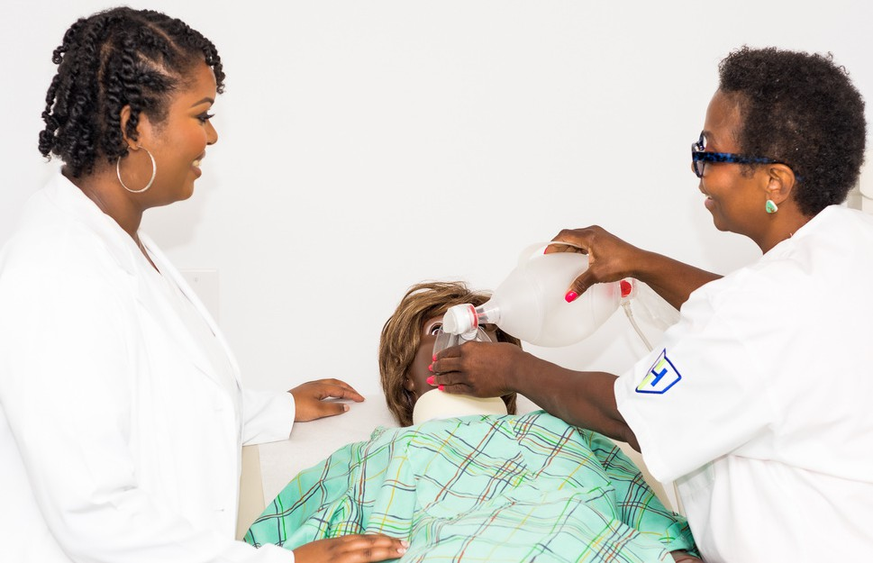

Medical Assistant Program

The Medical Assistant program is a comprehensive course designed to teach students the skills needed to provide care for patients in a clinic setting. The program focuses on both administrative and clinical competencies such anatomy and physiology of all body systems, administrative functions such as appointment scheduling, insurance billing, and office management, as well as clinical functions including administering medications, venipuncture skills, obtaining and recording medical histories and vital signs, medication administration, and preparation of the patient and treatment rooms for physician examinations. Students do not have to leave the school for clinicals as clinical may be conducted onsite in our lab. Upon completion, graduates may pursue a career in a clinical setting under the supervision of a licensed physician and function as a vital part of the healthcare team. Students have 5 years from the date of training to sit for the national exam to become a Certified Clinical Medical Assistant. To obtain a job in this career field, students do not have to be certified to work. It is up to the employer to require certification or if they will accept hands-on experience.

A certificate of completion is provided at the end of the course. Upon successful completion of the Medical Assistant program, students will be able to obtain jobs as a Medical Assistants, Phlebotomy Technicians, or EKG Technicians in the following areas:

- Private practices
- Urgent Care Clinics
- Outpatient Care Facilities
- Primary Care Offices
- VA clinics/hospitals
- Mobile Clinics
- Paramedical examiners

Course Hours:

600 Clock hours with 400 hours of (in- person) classroom/theory instruction and 200 hours in person lab instruction (in-person) Accelerated Day Class: 9:00am- 4:00pm M-Th (75 days or 18.75 weeks)
Evening Class: 5:00pm-9:00pm M-Th. (150 days or 37.5 weeks)


Program Objectives:
- Administrative Procedures
- Medical Records and Patient Information
- Patient Communication
- Universal Precautions
- Medical Terminology
- Medical History Obtainment and Documentation
- Obtaining Vital Signs
- Human Anatomy and Physiology Review
- Assisting and Medical Exams
- Blood Collection Equipment, Additives, and Order of Draw
- Venipuncture Procedures
- Microbiology
- Medication Administration
- Injections
- Scheduling Appointments
- Documentation and filing procedures
- Capillary Puncture Equipment, Principles and Procedures Special
- Collections and Point-of-Care Testing
- Medical Emergencies
- Urine and Other Non-blood Specimens and Tests
- ECG’s

Required Textbooks:
Textbook: Hartman's Medical Assisting: The Basics, Paula Holstein Webb, MS, BSN, RN, 2022, ISBN: 978-1-60425-148-7

Workbook: Hartman's Medical Assisting: The Basics, Paula Holstein Webb, MS, BSN, RN, 2022, ISBN: 978-1-60425-149-4

PREREQUISITE COURSES & OTHER REQUIREMENTS FOR ADMISSION TO PROGRAM / COURSE:

- Must be 16 years of age or older
- High School Diploma or GED
- Pass literacy exam with 75% or higher
- Government issued ID
- Social Security card
- Proof of Hep B Vaccine

Instructional Methods:
Instruction for this course will include lectures, PowerPoint presentations, case studies with discussion, and interactive games such as Kahoot and Jeopardy during lecture.

Self-study resources include skills videos and poster board assignments. In the lab students will engage in watching instructor demonstrations of skills, practicing clinical skills, and provide return demonstrations of those skills. There is also role play in the lab.

Student to Instructor Ratio 20:1
Program includes the following subject titles:
MA100: Introduction to Medical Assisting
Theory Contact Hours: 50 Lab Contact Hours: 0
This course identifies the duties and responsibilities of a Medical Assistant and explains the history of the medical profession. Distinguishes between the various organizations related to the profession of medical assisting; explains the need and importance of credentials; identifies training methods for becoming a medical assistant; discusses professional development; identifies healthcare trends and their relationship to the practice of medical assisting; identifies medical specialties.
Education related to therapeutic communication, diversity, and understanding behaviors is taught. Students will learn legal principles, healthcare laws such as HIPAA, and healthcare ethics.
MA200: Fundamentals of Ambulatory Care
Theory Contact Hours: 40 Lab Contact Hours: 20
This course identifies technologies used to care for patients, hardware use, ergonomics, and privacy/ security for patient information. Students will obtain an understanding of written communications, telephonic communications, and scheduling patient appointments. Understanding patient health records, HITECH, electronic medical records, dictation and transcription, and how-to document is an integral part of this course. Students will learn the daily operations of a clinic and how to maintain the safety of the location, supplies, and equipment. Students will apply the knowledge, skills, and logic they have learned in the classroom and practice it in a simulation lab setting. Students will execute every opportunity to engage in experiences to practice skills they have learned in the classroom and lab.
MA300: Coding and Billing

Theory Contact Hours: 40 Lab Contact Hours: 20

This course will teach students the essentials to healthcare billing and coding for provider reimbursement. Students will learn about health insurance plans, participating provider contracts, ICD-10-CM, third-party reimbursement, and diagnostic coding. Students will gain hands-on experience with the use of CPT manual, CPT codes, E/M codes, and knowledge of medical specialty guidelines. There is a heavy emphasis placed on obtaining an understanding of supporting documentation for insurance reimbursement for services. Students will apply the knowledge, skills, and logic they have learned in the classroom and practice it in a simulation lab setting. Students will execute every opportunity to engage in experiences to practice skills they have learned in the classroom and lab.

MA400: Advanced Ambulatory Care Administration

Theory Contact Hours: 40 Lab Contact Hours: 20

This course focuses on the understanding of patient account management and practice management. Students will learn about managing funds, bookkeeping, accounts receivable & Payable, employee payroll, and other advanced administrative roles. Students will have a solid understanding of what it takes to manage a clinic, policies, and procedures that should be followed and even employee hiring. The supportive role of managing a facility may be one that the clinical medical assistant may need to fulfill. Students will apply the knowledge, skills, and logic they have learned in the classroom and practice it in a simulation lab setting. Students will execute every opportunity to engage in experiences to practice skills they have learned in the classroom and lab.

MA500: Fundamentals of Clinical Assisting

Theory Contact Hours: 70 Lab Contact Hours: 20

This course provides students with knowledge as it relates to medical terminology, anatomy and physiology, acid-base balancing, infection control, and OSHA. An introduction to the human body and how it functions is conducted. Students will gain hands-on experience in obtaining vital signs, conducting a medical history intake, conducting assessments, and interviewing patients. Patient education and coaching along with nutrition and health promotion are essential to this unit. The ability to provide patient education is essential and practiced in this course.

Students will also engage in assisting with procedures and understanding commonly used procedure equipment. Asepsis, sterilization, and wound care are discussed and practiced. In this course, students understand and practice electrocardiogram tracing, and obtaining a 12 lead ECG. Students will also learn how to respond to medical emergencies in the healthcare setting with the proper supplies and equipment. Students will apply the knowledge, skills, and logic they have learned in the classroom and practice it in a simulation lab setting. Students will execute every opportunity to engage in experiences to practice skills they have learned in the classroom and lab.

MA600: Assisting with Medications

Theory Contact Hours: 60 Lab Contact Hours: 40

In this course, students will learn the fundamentals of medication administration, pharmacology, drug names, and interactions, how to use drug reference material and how to conduct mathematical equations to administer the correct drug dosages. Students will gain hands-on experience with drug labels, supplies such as syringes and needles, and will also prepare medication for administration as prescribed. Ex: injection, inhalation or oral route. Students will apply the knowledge, skills, and logic they have learned in the classroom and practice it in a simulation lab setting. Students will execute every opportunity to engage in experiences to practice skills they have learned in the classroom and lab.

MA700: Assisting with Medical Specialties

Theory Contact Hours: 40 Lab Contact Hours: 40

In this course, students will learn how to work in specialized departments such as Ophthalmology, Otolaryngology, Dermatology, Allergies, Infectious Disease, Gastroenterology, Orthopedic, Rheumatology, Neurology, Behavior Health, Endocrinology, Cardiology, Pulmonology, Urology, OB, Pediatrics, and Geriatric. A breakdown of human anatomy and disease processes related to these specialties are discussed and applied with hands-on training. Examples: Cast application/ removal, specimen collection, and assisting with gynecological exams. Students will apply the knowledge, skills, and logic they have learned in the classroom and practice it in a simulation lab setting. Students will execute every opportunity to engage in experiences to practice skills they have learned in the classroom and lab.

MA800: Assisting with Clinical Laboratory Procedures

Theory Contact Hours: 40 Lab Contact Hours: 40

In the course students learn about the different personnel in the clinical laboratory, governing legislation, quality assurance guidelines, specimen collection, storage and handling, and CLIA waived Testing. Students will gain hands-on experience with blood collection, the order of draw, proper use of equipment for a blood draw, and techniques for a blood draw. Understanding the different types of lab testing, reference panels, and microbiology related to lab testing is reviewed for student understanding and application. Students will apply the knowledge, skills, and logic they have learned in the classroom and practice it in a simulation lab setting. Students will execute every opportunity to engage in experiences to practice skills they have learned in the classroom and lab.

MA900: Job Seeking

Theory Contact Hours: 20 Lab Contact Hours: 0

In the course, students learn how to put everything they have learned together so they are able to market themselves in the workforce. Students will learn about the work ethics and personality traits employers are looking for. Understanding how to relay qualifications for employment on resumes, cover letters, and even the interview is discussed. Students will learn to look for jobs that fit their personal goals, interests, and needs. Students will engage in mock interviews to help them prepare for the workforce. Students will apply the knowledge, skills, and logic they have learned in the classroom and practice it in a simulation lab setting. Students will execute every opportunity to engage in experiences to practice skills they have learned in the classroom and lab.

Hybrid Medical
Assistant Program



Hybrid Medical Assistant Program

The Medical Assistant program is a comprehensive course designed to teach students the skills needed to provide care for patients in a clinic setting. This course includes online and in person instruction. The program focuses on both administrative and clinical competencies such anatomy and physiology of all body systems, administrative functions such as appointment scheduling, insurance billing, and office management, as well as clinical functions including administering medications, venipuncture skills, obtaining and recording medical histories and vital signs, medication administration, and preparation of the patient and treatment rooms for physician examinations. Upon completion, graduates may pursue a career in a clinical setting under the supervision of a licensed physician and function as a vital part of the healthcare team. Students do not have to leave the school for clinicals as clinical may be conducted onsite in our lab. Students have 5 years from the date of training to sit for the national exam to become a Certified Clinical Medical Assistant. To obtain a job in this career field, students do not have to be certified to work. It is up to the employer to require certification or if they will accept hands-on experience.

Students who elect for the hybrid course option can expect to engage in online learning for the classroom/ theory portion of the course. Online learning will be a live lecture conducted via Zoom. Students will conduct live assessments through gamification while in lecture. Students will also engage in quiz questions via online forms that are auto submitted to their instructor. These items along with course syllabus and presentations will be in the students learning management system. All tests will be conducted in person prior to the student’s lab experiences.

A certificate of completion is provided at the end of the course. Upon successful completion of the Medical Assistant program, students will be able to obtain jobs as a Medical Assistants, Phlebotomy Technicians, or EKG Technicians in the following areas:

- Private practices
- Urgent Care Clinics
- Outpatient Care Facilities
- Primary Care Offices
- VA clinics/hospitals
- Mobile Clinics
- Paramedical examiners

Course Hours:

600 Clock hours with 400 hours of online instruction and 200 hours in person lab instruction in person
Accelerated Day Class: 9:00am-4:00pm M-Th (75 days or 18.75 weeks)
Evening Class: 5:00pm-9:00pm M-Th. (150 days or 37.5 weeks)


Program Objectives:
- Administrative Procedures
- Medical Records and Patient Information
- Patient Communication
- Universal Precautions
- Medical Terminology
- Medical History Obtainment and Documentation
- Obtaining Vital Signs
- Human Anatomy and Physiology Review
- Assisting and Medical Exams
- Blood Collection Equipment, Additives, and Order of Draw
- Venipuncture Procedures
- Microbiology
- Medication Administration
- Injections

- Scheduling Appointments
- Documentation and filing procedures
- Capillary Puncture Equipment, Principles and Procedures
- Special Collections and Point-of-Care Testing
- Medical Emergencies
- Urine and Other Non-blood Specimens and Tests
- ECG’s

Required Textbooks:
Textbook: Hartman's Medical Assisting: The Basics, Paula Holstein Webb, MS, BSN, RN, 2022, ISBN: 978-1-60425-148-7

Workbook: Hartman's Medical Assisting: The Basics, Paula Holstein Webb, MS, BSN, RN, 2022, ISBN: 978-1-60425-149-4

PREREQUISITE COURSES & OTHER REQUIREMENTS FOR ADMISSION TO PROGRAM / COURSE:

- Must be 16 years of age or older
- High School Diploma or GED
- Pass literacy exam with 75% or higher
- Government issued ID
- Social Security card
- Proof of Hep B Vaccine

Instructional Methods:

Instruction for this course will include lectures, PowerPoint presentations, case studies with discussion, and interactive games such as Kahoot and Jeopardy during lecture. Self-study resources include skills videos and poster boards with video explanation assignments. In the lab students will engage in watching instructor demonstrations of skills, practicing clinical skills, and provide return demonstrations of those skills. There is also role play in the lab.

Student to Instructor Ratio 20:1
Program includes the following subject titles:
HMA100: Introduction to Medical Assisting

Theory Contact Hours: 50 Lab Contact Hours: 0

This course identifies the duties and responsibilities of a Medical Assistant and explains the history of the medical profession. Distinguishes between the various organizations related to the profession of medical assisting; explains the need and importance of credentials; identifies training methods for becoming a medical assistant; discusses professional development; identifies healthcare trends and their relationship to the practice of medical assisting; identifies medical specialties. Education related to therapeutic communication, diversity, and understanding behaviors is taught. Students will learn legal principles, healthcare laws such as HIPAA, and healthcare ethics.

HMA200: Fundamentals of Ambulatory Care

Theory Contact Hours: 40 Lab Contact Hours: 20

This course identifies technologies used to care for patients, hardware use, ergonomics, and privacy/ security for patient information. Students will obtain an understanding of written communications, telephonic communications, and scheduling patient appointments. Understanding patient health records, HITECH, electronic medical records, dictation and transcription, and how-to document is an integral part of this course. Students will learn the daily operations of a clinic and how to maintain the safety of the location, supplies, and equipment. Students will apply the knowledge, skills, and logic they have learned in the classroom and practice it in a simulation lab setting. Students will execute every opportunity to engage in experiences to practice skills they have learned in the classroom and lab.

HMA300: Coding and Billing

Theory Contact Hours: 40 Lab Contact Hours: 20

This course will teach students the essentials to healthcare billing and coding for provider reimbursement. Students will learn about health insurance plans, participating provider contracts, ICD-10-CM, third-party reimbursement, and diagnostic coding. Students will gain hands-on experience with the use of CPT manual, CPT codes, E/M codes, and knowledge of medical specialty guidelines. There is a heavy emphasis placed on obtaining an understanding of supporting documentation for insurance reimbursement for services. Students will apply the knowledge, skills, and logic they have learned in the classroom and practice it in a simulation lab setting. Students will execute every opportunity to engage in experiences to practice skills they have learned in the classroom and lab.

HMA400: Advanced Ambulatory Care Administration

Theory Contact Hours: 40 Lab Contact Hours: 20

This course focuses on the understanding of patient account management and practice management. Students will learn about managing funds, bookkeeping, accounts receivable & Payable, employee payroll, and other advanced administrative roles. Students will have a solid understanding of what it takes to manage a clinic, policies, and procedures that should be followed and even employee hiring. The supportive role of managing a facility may be one that the clinical medical assistant may need to fulfill. Students will apply the knowledge, skills, and logic they have learned in the classroom and practice it in a simulation lab setting. Students will execute every opportunity to engage in experiences to practice skills they have learned in the classroom and lab.

HMA500: Fundamentals of Clinical Assisting

Theory Contact Hours: 70 Lab Contact Hours: 20

This course provides students with knowledge as it relates to medical terminology, anatomy and physiology, acid-base balancing, infection control, and OSHA. An introduction to the human body and how it functions is conducted. Students will gain hands-on experience in obtaining vital signs, conducting a medical history intake, conducting assessments, and interviewing patients. Patient education and coaching along with nutrition and health promotion are essential to this unit. The ability to provide patient education is essential and practiced in this course. Students will also engage in assisting with procedures and understanding commonly used procedure equipment. Asepsis, sterilization, and wound care are discussed and practiced. In this course, students understand and practice electrocardiogram tracing, and obtaining a 12 lead ECG. Students will also learn how to respond to medical emergencies in the healthcare setting with the proper supplies and equipment. Students will apply the knowledge, skills, and logic they have learned in the classroom and practice it in a simulation lab setting. Students will execute every opportunity to engage in experiences to practice skills they have learned in the classroom and lab.

HMA600: Assisting with Medications

Theory Contact Hours: 60 Lab Contact Hours: 40

In this course, students will learn the fundamentals of medication administration, pharmacology, drug names, and interactions, how to use drug reference material and how to conduct mathematical equations to administer the correct drug dosages. Students will gain hands-on experience with drug labels, supplies such as syringes and needles, and will also prepare medication for administration as prescribed. Ex: injection, inhalation or oral route. Students will apply the knowledge, skills, and logic they have learned in the classroom and practice it in a simulation lab setting. Students will execute every opportunity to engage in experiences to practice skills they have learned in the classroom and lab.

HMA700: Assisting with Medical Specialties

Theory Contact Hours: 40 Lab Contact Hours: 40

In this course, students will learn how to work in specialized departments such as Ophthalmology, Otolaryngology, Dermatology, Allergies, Infectious Disease, Gastroenterology, Orthopedic, Rheumatology, Neurology, Behavior Health, Endocrinology, Cardiology, Pulmonology, Urology, OB, Pediatrics, and Geriatric. A breakdown of human anatomy and disease processes related to these specialties are discussed and applied with hands-on training. Examples: Cast application/ removal, specimen collection, and assisting with gynecological exams. Students will apply the knowledge, skills, and logic they have learned in the classroom and practice it in a simulation lab setting. Students will execute every opportunity to engage in experiences to practice skills they have learned in the classroom and lab.

HMA800: Assisting with Clinical Laboratory Procedures

Theory Contact Hours: 40 Lab Contact Hours: 40

In the course students learn about the different personnel in the clinical laboratory, governing legislation, quality assurance guidelines, specimen collection, storage and handling, and CLIA waived Testing. Students will gain hands-on experience with blood collection, the order of draw, proper use of equipment for a blood draw, and techniques for a blood draw. Understanding the different types of lab testing, reference panels, and microbiology related to lab testing is reviewed for student understanding and application. Students will apply the knowledge, skills, and logic they have learned in the classroom and practice it in a simulation lab setting.
Students will execute every opportunity to engage in experiences to practice skills they have learned in the classroom and lab.

HMA900: Job Seeking

Theory Contact Hours: 20 Lab Contact Hours: 0

In the course, students learn how to put everything they have learned together so they are able to market themselves in the workforce. Students will learn about the work ethics and personality traits employers are looking for. Understanding how to relay qualifications for employment on resumes, cover letters, and even the interview is discussed. Students will learn to look for jobs that fit their personal goals, interests, and needs. Students will engage in mock interviews to help them prepare for the workforce.

FEES, TUITIONS AND/OR SPECIAL CHARGES
Phlebotomy Technician Program/ Hybrid-Phlebotomy Technician Program
Tuition and fees
$150 Course Registration
$1369 Course Tuition
$25 CPR
$169 National Certification Exam
$100 Textbook
$50 Workbook
$30 Uniform
$150 Lab Supplies
$2,048 Total
Replacement Costs
$100 Book
$30 Uniform
$50 Workbook

Medical Assistant Program/ Hybrid-Medical Assistant Program
Tuition and fees
$150 Course Registration
$5456 Course Tuition
$250 Textbook
$150 Workbook
$100 Uniform
$25 CPR
$169 National Certification Exam
$1050 Lab Supplies
$150 Clinical Rotation
$7500 Total
Replacement Costs
$250 Textbooks
$100 Uniform
$150 Workbook

Patient Care Technician/ Hybrid-Patient Care Technician
Tuition and fees Replacement Costs
$150 Course Registration $150 Textbooks
$2506 Course Tuition $100 Uniform
$150 Textbook $100 Workbook
$100 Workbook
$100 Uniform
$25 CPR
$169 National Certification Exam
$400 Lab Equipment
$3600 Total

H.E.R.O Institute accepts payment in the following methods: Credit Card, Cash, Debit Card, money order or certified funds check. No personal checks will be accepted.

Financial Aid:
H.E.R.O Institute is committed to making healthcare career education affordable and accessible. H.E.R.O Institute has partnered with CobbWorks as the local administrator of the State of Georgia's Workforce Innovation and Opportunities Act (WIOA) funds. Students of the Phlebotomy Technician Program may be eligible for partial or complete tuition coverage under WIOA. Additional programs may be available for WIOA funding in the future once program eligibility requirements are met. Contact admin@heroinstitute.com to set up an eligibility consultation.

HOLIDAYS TO BE OBSERVED
New Year’s Eve Independence Day
New Year’s
Martin Luther King Day
Presidents’ Day
Juneteenth
Good Friday
Memorial Day

Labor Day
Veteran’s Day
Thanksgiving Day
Black Friday
Christmas Eve
Christmas

Students should submit for enrollment to a program 5 business days before the start of the course.

COURSE ENROLLMENT DATES:

Course dates with a * indicate a vacation week is observed. Please see the vacation schedule.
Phlebotomy Technician Day Classes: Hybrid or In-person
First Day of Class | Mid Term | Last Day of Course | Theory Make-Up Day | Lab Make-Up Day
6/1/26 | 6/12/26 | 6/26/26 | 6/25/26 | 6/29/26
7/20/26 | 7/31/26 | 8/13/26 | 8/12/26 | 8/14/26
8/31/26 | 9/14/26 | 9/25/26 | 9/24/26 | 9/28/26
10/5/26 | 10/9/26 | 10/16/26 | 10/13/26 | 10/19/26
11/30/26 | 12/4/26 | 12/10/26 | 12/7/26 | 12/11/26
1/25/27 | 1/29/27 | 2/4/27 | 2/1/27 | 2/5/27
3/15/27 | 3/19/27 | 3/25/27 | 3/22/27 | 3/29/27
4/5/27 | 4/16/27 | 4/29/27 | 4/28/27 | 4/30/27
5/17/27 | 5/28/27 | 6/11/27 | 6/10/27 | 6/14/27

Phlebotomy Technician Evening Classes: Hybrid or In-person
First Day of Class | Mid Term | Last Day of Course | Theory Make-Up Day | Lab Make-Up Day
8/31/26 | 9/21/26 | 10/9/26 | 10/8/26 | 10/13/26
12/7/26 | 12/29/26 | 1/21/27 | 1/20/27 | 1/22/27
1/25/27 | 2/12/27 | 3/5/27 | 3/4/27 | 3/8/27
3/15/27 | 3/12/27 | 3/11/27 | 3/10/27 | 3/12/27
5/3/27 | 5/21/27 | 6/11/27 | 6/10/27 | 6/14/27
Patient Care Technician Day Classes: Hybrid or In-person
First Day of Class | Mid Term | Last Day of Course | Theory/Lab Make-Up Day | Clinical Make-Up Day
6/29/26 | 8/18/26 | 10/8/26 | 10/7/26 | 10/13/26
2/22/27 | 4/13/27 | 6/3/27 | 6/2/27 | 6/7/27

Patient Care Technician Evening Classes: Hybrid or In-person
First Day of Class | Mid Term | Last Day of Course | Theory/Lab Make-Up Day | Clinical Make-Up Day
6/29/26 | 9/1/26 | 11/5/26 | 11/4/26 | 11/9/26
11/16/26 | 1/26/27 | 3/31/27 | 3/30/27 | 4/1/27

Medical Assistant Day Classes: In-Person or Hybrid

First Day of Class | Mid Term | Last Day of Course | Theory/Lab Make-Up Day | Clinical Make-Up Day
6/29/26 | 11/9/26 | 3/29/27 | 3/25/27 | 3/30/27
4/5/27 | 4/1/27 | 3/31/27 | 3/30/27 | 4/1/27

Medical Assistant Evening Classes: In-Person or Hybrid

We do not currently have evening classes scheduled for 2027. More Info TBA

SCHEDULED VACATION PERIODS
We are closed the week of Thanksgiving annually.

We are closed for two weeks during Christmas and New Year’s annually.

We are closed the first week of April for Spring Break.

OFFICE HOURS
We offer day and evening course offerings to help you meet your career goals.

Office hours for enrollment:
Monday, Tuesday, Thursday: 9:00am-4:00pm
Wednesdays: 9:00am- 6:00pm

EMERGENCIES AND INCLEMENT WEATHER
In the event of an emergency, the school will notify students of any class delay or cancellation via the Remind app. In the event of inclement weather, such as ice, sleet, flooding or any other natural weather or local disaster students will be notified via the Remind app of closure or delays.

When class/clinical is delayed, the time must be made up prior to the completion of course per federal regulations. Course make up dates are predesignated on the course calendar. Please see the course calendar above. However, in the event of multiple emergencies or inclement weather issues every effort will be made to arrange with students for a common make up day. This may result in the student finishing class with the next scheduled class.

CREDIT FOR PREVIOUS EDUCATION, TRAINING, OR EXPERIENCE
There are no credit transfer agreements with any other institution for this program. Please note that any other experience or education doesn’t transfer or count as hour credits to the nurse aide training program.

Students will not be able to transfer hours completed at H.E.R.O Institute. Transfer students from another state nurse aide program will have to contact their state's nurse aide regulatory body to inquire about the ability to practice as a nurse aide in Georgia. If it is decided that a person must retake the nurse aide training program, no credit will be given for previous knowledge or certification for the nurse aide training program.

CANCELLATION AND REFUND POLICIES
A full refund will be made to any student who cancels the enrollment contract within 72 hours (until midnight of the third day excluding Saturdays, Sundays and legal holidays) after the enrollment contract is signed or if no contract is signed and prior to the classes beginning the student requests a refund within 72 business hours after making the payment. H.E.R.O Institute will refund any unused portion of the fees if a student withdraws before completing fifty (50) percent of the period of enrollment except for items that were special ordered for a particular student and cannot be used or sold to another student and items that were returned in a condition that prevents them from being used by or sold to new students. The school also will not refund fees for goods and/or services provided by third party vendors. Refunds will be calculated based on the date in which the student has begun the formal withdrawal process. Refunds will be issued to the student in full via US mail in the form of a check within 45 days of the date of withdrawal.

REFUND POLICY

A full refund of all tuition and fees is due and refundable in each of the following cases:

- an enrollee is not accepted by the school;
- if the course of instruction is discontinued by the school and this prevents the student from completing the course; or
- if the student's enrollment was procured as a result of any misrepresentation in advertising, promotional materials of the school, or representations by the owner or representatives of the school.

A full refund will be made to any student who cancels the enrollment contract within 72 hours (until midnight of the third day excluding Saturdays, Sundays and legal holidays) after the enrollment contract is signed or if no contract is signed and prior to the classes beginning the student requests a refund within 72 business hours after making the payment. Withdraw must be requested via the withdrawal form and submitted to the school or via email to admin@heroinstitute.com.

Refunds will be sent via check US mail to the address on file or requested per student for formal withdrawals.

All refunds shall be made without requiring a request from the student and within forty-five (45) days from the date that the institution terminates the student or determines withdrawal by the student.

- Refunds for Classes Canceled by the Institution:
If tuition and fees are collected in advance of the start date of the program and the institution cancels the class, 100% of the tuition and fees collected will be refunded. The refund shall be made within forty-five (45) days of the planned start date.

- Refunds for a student that does not start class or requests cancellation within three (3) days after signing the contract:
If tuition and fees are collected in advance of the start date and the student does not begin class, 100% of the tuition and fees collected will be refunded. The refund will be made within forty-five (45) days of the class start date.

- Refunds for Withdrawal after Class Commences and more than three (3) business days after signing the contract:
(i)Refunds are determined based on the proportion of the tuition and percentage of the program completed at withdrawal, up to 50% of the program.

- If a student withdraws after completing 50% of the program, no refund of tuition is required.

GRADING POLICY:
Grades evaluation will be separate for classroom, lab and clinicals. Theory evaluation will be based on the average grade of all exams. Lab practice will be a Pass/Fail system based on performance observation by the instructor. Students must receive an overall course grade of 70% in order to pass the theory portion of the course and a pass in clinical/lab. receive a certificate of completion to take the state exam to become a nurse aide.

Numerical Grade | Letter Grade | Grade Point
100-90 | A | 4.0
89-80 | B | 3.0
79-70 | C | 2.0
69-60 | D | 1.0
Below 60 | F | 0.0
Incomplete | I | 0.0
Withdraw | W | 0.0

CERTIFICATE AWARDED
Students graduating from our courses with a 70% or higher and pass in both lecture and lab will receive a certificate of completion which allows them to sit for the state exam to become nationally certified in their field.

SATISFACTORY PROGRESS
To remain in good standing and receive a certificate of completion, students must maintain at least a minimum grade point average of 2.00. Students will receive written notification of their progress at the midpoint.

A written numeric grade report will be given to the student for the classroom portion of the course and progress in lab/ clinical will be provided separately. A student who is not making satisfactory progress at the midpoint will be placed on academic probation for the remainder of the progress evaluation period. The course instructor will counsel the student placed on probation prior to the student returning to class. The date, action taken, and terms of probation will be clearly indicated in the student's permanent file. If the student does not achieve the probationary standards set forth, the student will not be able to pass the course.

Students who fail the course will be able to re-enroll one additional time in an attempt to take the course or any other course offerings. If a student enrolls twice and fails both times, the student will not be able to re-enroll into H.E.R.O Institute. Such reenrollment does not circumvent the approved refund policy not do funds paid for the previous course transfer to the next course. A student who returns after termination of enrollment for unsatisfactory progress will be placed on academic probation for the next grading period. The student will be advised of this action, and it will be documented in the student's file. If the student does not demonstrate satisfactory progress at the end of this probationary period, the student's enrollment will be terminated. Please note students will be responsible for any tuition due for re-enrollment.
NOTE: Prior tuitions paid do not transfer to the second enrollment.

ACADEMIC PROBATION/ TERMINATION
A student who is not making satisfactory progress as defined above by course mid-point, will be placed on academic probation. If a student on academic probation fails to achieve satisfactory progress the student's enrollment will be terminated. Students terminated for unsatisfactory progress cannot continue the course and will be allowed to re-enter the program one additional time upon the
next course offering. Students must note any grades, work, or payment made prior to termination to NOT carry over to the next course enrollment.

When a student is placed on academic probation, the school will counsel the student prior to the student resuming the class. The date, action taken, and terms of probation will be clearly indicated in the student's permanent file.

The school will place a student who returns after his/her enrollment was terminated for unsatisfactory progress on academic probation until the mid-point evaluation. The school will advise the student of this action, and it will be documented in the student's file. If the student does not demonstrate satisfactory progress by mid-point, that student's enrollment will be terminated. Students terminated due to academic reasons are responsible for tuition in full if they choose to re-enroll. Tuition from the prior course will not be transferred.

INCOMPLETES & WITHDRAWAL:
An "I" for incomplete is assigned when all the work of a subject class cannot be completed due to circumstances beyond the control of the student. Situations will be assessed by the program coordinator on a case-by-case basis.

A "W" for Withdrawal indicates that the student officially withdrew or was administratively withdrawn from the subject class. A student with a grade of "W" cannot complete the course of study, and will be issued a refund in accordance with the refund policy below.

REMEDIAL WORK AND REPEAT COURSES
H.E.R.O Institute does not offer remedial work. Students who miss class must attend a make-up session and must complete the work they missed from the missed class. Students who must repeat the course due to termination or withdrawal must repeat the course in its entirety. Students who fail the nursing assistant training program only have two attempts to re-take the course. After the second attempt and if the student fails, they are unable to re-enter the course again.

ATTENDANCE POLICY
Students are expected to attend all lectures and labs as scheduled. Instructors will maintain a daily record of attendance for each class at the beginning of class and after each break. A tardy is defined as arriving in class 10 minutes after the start of class. Students are considered late from breaks when returning more than 5 minutes late from the start of class. Any student that has been marked tardy 3 times must attend the make-up session designated at the beginning of the course. Students may only attend the predesignated make-up day as seen in the above course schedule and no additional make up day will be arranged. Students who do not attend the predesignated make-up day will be terminated from the course.
Students whose enrollments are terminated for violation of the attendance policy will only have one attempt to re-enter the course during the next course offering.
If a student misses a day of class (absence), the student must attend the pre- designated make-up date as seen in the course schedule above.

Students in the Phlebotomy Technician and Patient Care Technician course are only allowed to miss 2 days of class and both days must be made up. If a student misses 3 days or more, they will be terminated from the program.

Students in the Medical Assistant Course are only allowed to miss 4 days of class and all 4 days must be made up. If a student misses more than 5 days or more, they will be terminated from the program.

Leave of absence will not be granted to students. Students must withdraw and re- enroll in the nursing assistant training program when ready to attend the course.

MAKE-UP WORK
No more than 5% of the total course time hours for a course may be made up. Make-up work shall:
- be supervised by an instructor approved for the class being made up;

- require the student to demonstrate substantially the same level of knowledge or competence expected of a student who attended the scheduled class session;
- be completed within two weeks of the end of the grading period during which the absence occurred;
- be documented by the school as being completed, recording the date, time, duration of the make-up session, and the name of the supervising instructor; and
- be signed and dated by the student to acknowledge the make-up session.

SCHOOL POLICY REGARDING STUDENT CONDUCT
Students may be terminated from the program if they violate any policies or conduct rules. Students who are terminated for violation of these policies will not be eligible for re-enrollment. Some reasons for termination include but are not limited to:

- Theft of supplies from the school, or clinical site whether it be from the school, a resident or another student. Theft of any kind will NOT be tolerated or possessions from clinical sites, patients/residents, the school, other students or employees of the school or clinical agencies.

- Destruction of school property, clinical property, resident property or another student’s property.

- Engaging in disruptive behavior, including foul language, horse play or creating a disturbance in class, campus or clinical sites.

- Falsifying any documents related to enrollment, educational documents or resident records.

- Non-adherence to school uniform requirements while in class or clinical. This includes proper scrub colors, uniform free of wrinkles, free of offensive odors, artificial nails, etc.

- Engaging in unsafe care related to patient safety or the safety of other students will not be tolerated.

- Posting inappropriate content, graphics and verbiage to social media while in the program that undermines the rights/ beliefs of patients or that is considered undesirable/ inappropriate in general.

- Engaging in resident abuse or neglect.

- The use, sale, or possession of alcohol, drugs or controlled substances or being under the influence of alcohol or drugs on campus or at clinical.

- Student refusal or failure to follow direct instructions from course instructors, clinical instructors or nurses at the clinical will not be tolerated.

- Possession of weapons such as guns, knives, explosives or other weapons on campus or at clinical sites.

- Students are not allowed to use electronic devices while on the clinical floor, lab or in the classroom.

- Plagiarism or academic dishonesty.

- Students engaging in HIPAA Health Insurance Portability Accountability Act (HIPAA) violations.

- Students engaging in harassment be it sexual, racial or cultural will not be tolerated on campus or at clinical.

- Students taking pictures of residents/ patients and keeping them for themselves or posting them on social media.

- No excessive sitting or sleeping during clinical. No leaving during clinical rotation.

- No attending or going to clinicals without the instructor’s permission or being on site.

SEXUAL HARASSMENT POLICY:
Unwelcome sexual advances, requests for sexual favors, and other verbal or physical conduct of a sexual nature constitute sexual harassment when

- submission to such conduct is made either explicitly or implicitly a term or condition of an individual's employment,

- submission to or rejection of such conduct by an individual is used as the basis for employment decisions affecting such individuals, or

- such conduct has the purpose or effect of unreasonably interfering with an individual's work performance or creating an intimidating, hostile, or offensive working environment.

Reenrollment after dismissal/ termination for any violation of student conduct is not allowed.

Dress Code:

Phlebotomy Technician: Navy Blue Scrubs Patient Care Technician: White Scrubs Medical Assistant: Green Scrubs
Students must wear scrubs to lab and classroom settings. A school issued ID badge must be worn daily. Shoes must be white or black leather and closed toe.

REQUIREMENTS FOR GRADUATION
Students will receive a certificate of completion once all hours of instruction and lab are completed with a grade of passing for the Phlebotomy Technician, Patient Care Technician, and Medical Assistant program. A grade of 70% in the didactic/class, a grade of pass in the lab must be achieved in order for a student to successfully graduate from the course.

TRANSCRIPT
Upon graduation from the program, students will receive a copy of their transcript free of charge. Students who would like an additional transcript must submit a written request to the Program Director along with a fee of $7 to receive an official copy of their program transcript.

TRANSFER OF CREDIT HOURS
Students planning to transfer should check the transfer institution’s requirements/guides or discuss their options with an academic advisor or counselor. H.E.R.O Institute does not have a transfer agreement with any school or institution. Students who wish to transfer should know hours from the nurse aide training program may not transfer to other institutions.

STUDENT GRIEVANCES/COMPLAINTS
Student complaints are defined as any student concern regarding the school programs, services or staff. A student who has a concern about a school-related issue is encouraged to submit a grievance form to the program coordinator for resolution as soon as possible. The program coordinator will schedule a meeting with all involved parties within 48 business hours of student filing. If needed an investigation will be conducted by the administrator and program coordinator with final finding to be delivered to the student within 5 business days of the student initial complaint filing.

The Commission requires that students utilize and complete their institution's grievance procedure in an attempt to resolve any complaint or concern before submitting a complaint to the Commission. If the institution’s resolution is not satisfactory, a student may then appeal to the Commission, but it will not investigate a complaint unless the student has exhausted all available grievance procedures outlined by the institution.

You may contact Georgia NPEC at online at https://gnpec.georgia.gov/student- resources/student-complaints or contact them at

Georgia Nonpublic Postsecondary Education Commission 2082 East Exchange Place Suite: 220
Tucker, GA 30084
770-414-3300

READMISSION POLICY
Readmissions to H.E.R.O Institute is only grated to students who have a withdraw or incomplete on their transcript. Students may reapply to the program during the next class offering. If a student is not successful in completion of a course offered by H.E.R.O Institute after the second attempt, the student is not eligible for another re-admittance to that program or any other program offered by H.E.R.O Institute. Students must formally enroll during readmittance and are required to pay for all student tuition despite any fees paid during the last course enrollment. Students who have been terminated from the program are not eligible to readmittance.

CAREER SERVICES:
H.E.R.O Institute provides students with the tools and resources needed to acquire a position in the workforce as well as job referrals. We cannot not guarantee job placement. Graduates of our program will receive access to job opportunities in their area to which they can apply. This information is provided upon graduation, and job opportunities are also listed on our job board in our school.

Prior to the completion of the program of study, students will be provided with:

- Instruction on resume preparation
- How to conduct job searches
- Understanding interviewing skills
- Understanding how to accept and negotiate job offers
- Access to employer contact list

Students will be provided with an opportunity to meet with the program coordinator to discuss local job opportunities and be provided with leads. There will also be a job board located in school for students to review for potential jobs.

CRIMINAL BACKGROUND:
H.E.R.O Institute does not conduct criminal background checks. Students should know that any criminal background offences they have may prevent them from obtaining employment per employer policy. These policies vary per employer.
H.E.R.O Institute cannot be held accountable for students who complete the program but are unable to obtain employment due to criminal background or criminal allegation.

ENROLLMENT, PLACEMENT, GRADUATION INFO:

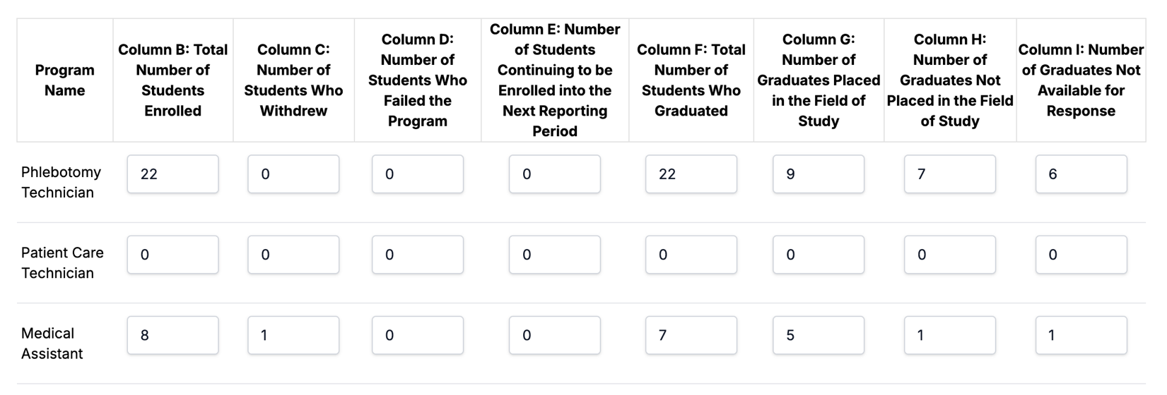

STUDENT DISCLOSURE FORM FOR H.E.R.O Institute
6130 Hotel Street, Austell, GA 30106

- Enrollment Agreement & Catalog I have read and received a copy of the enrollment agreement, or equivalent document, and the school catalog. I understand that the terms and conditions of these documents are not subject to amendment or modification by oral agreements. Student’s Initials

- School Outcomes I have read and received a copy of the school’s self-reported, unaudited retention, graduation, and placement rates for the preceding year as well as the most recent Georgia licensure test results, if applicable, for the program I am entering.
Student’s Initials

- Employment I understand that upon successful completion of my training program, this school will provide placement assistance. However, I understand that the school does not guarantee any graduate a job. I have not been guaranteed employment to earn a specific salary range upon graduation.
Student’s Initials

- Refund Policy I have reviewed the refund policy provided in the catalog and am aware that the institution attests to the fact that this policy meets the Minimum Standards set forth by the Georgia Nonpublic Postsecondary Education Commission.
Student’s Initials

- Complaint Procedure I have reviewed the complaint procedure provided in the catalog and am aware that, after exhausting the institution’s procedure, I have the right to appeal the institution’s complaint determination to the Georgia Nonpublic Postsecondary Education Commission. Student’s Initials

- Authorization and Accreditation Status I understand that the institution in which I am enrolling has been issued a Certificate of Authorization by the Georgia Nonpublic Postsecondary Education Commission. This status indicates that the institution has met the Minimum Standards established by Georgia Code (§20-3-250.6). Although authorized, I understand that this institution is not accredited by a U.S.-based accrediting association recognized by the United States Secretary of Education; therefore, I am not eligible for Federal Student Aid. Additionally, as is the case with all postsecondary institutions, both accredited and unaccredited, there is no guarantee that my credits will transfer to another institution.
Student’s Initials

Student’s Signature: Date:

School Representative’s Signature: Date:

*Students must receive a copy of this form, and a copy must be kept in the student’s file.
Student Forms

Laboratory Procedures Agreement
I, the undersigned, volunteer for venipuncture and micro-collection procedures to be performed on me as part of the Phlebotomy Technician, Phlebotomy, and Medical Assistant Program. I am aware that these are invasive procedures and there are risks such as hepatitis, HIV, and other diseases. I have no knowledge of having any communicable disease such as hepatitis, HIV, or other diseases such as anemia, cancer, TB, etc. I understand that I may only perform venipunctures and micro-collections within the lab/practicum setting and under the supervision of the instructor(s) or practicum supervisor(s). I do not hold H.E.R.O Institute, faculty, or classmates responsible for any untoward effect from these procedures. If applicable, I will obtain a physician’s excuse which will exempt me from either/or both venipuncture and/or micro-collection procedures to be performed on me before the beginning of the phlebotomy portion of the course. The physician will need to specify which technique(s) I will be exempted from. My grade will not be jeopardized by an exemption from these procedures. I agree to follow all lab rules and procedures as explained in this catalog and the additional rules and procedures listed below for my protection and the safety of others.

  - Wear PPE (Personal Protective Equipment) when handling any biohazard specimen or chemical
  - Disinfect the work area before and after procedures, immediately if there is a spill
  - Discard all contaminated materials into an appropriately labeled biohazard container. A rigid puncture-proof container, (Sharps), must be used for disposal of any object that would puncture a garbage bag, i.e. needles and lancets
  - Wear safety goggles when working with chemicals or when splashes are likely to occur
  - Avoid testing, smelling, or breathing chemicals
  - Follow the manufacturer’s instructions for operating equipment
  - Handle equipment with care and store chemicals properly
  - Report any broken or frayed electrical cord to your instructor
  - Discard any broken glassware into a “Sharps” container
  - Use appropriate chemical spill kits to clean up spills
  - Report any accident to your instructor

Student signature: Date:
I have received a copy of the H.E.R.O Institute Catalog/ Policy and Procedure. I have read, understood and agreed to abide by the document's contents as evidence of my signature below.

Signature Date

Witness Date

PHOTOGRAPHS CONSENT, WAIVER, AND RELEASE
I, , CONSENT AND GIVE PERMISSION TO H.E.R.O
Institute to photograph my Nurse Assistant Training. I understand that any such photographs, and all rights associated with them, will belong solely and exclusively TO H.E.R.O Institute, which shall have the absolute right to copyright, duplicate, reproduce, alter, display, distribute, and/or publish them in any manner, for any purpose, and in any form including, but not limited to, print, electronic, video, and/or Internet.

I voluntarily waive any and all rights with respect to any such photographs, including compensation, copyright, and privacy rights and any right to inspect or approve such photographs and/or copy, print or other materials that may be used in connection with them. I hereby release and discharge, and agree to hold harmless, Assured and Associates, its officers, agents and employees, and all persons acting under its permission or authority, from any TO H.E.R.O Institute claims and liability in connection with such photographs and/or their use.

I HAVE READ AND FULLY UNDERSTAND THE CONTENTS OF THIS CONSENT, WAIVER, AND RELEASE FORM, AND I SIGN IT FREELY AND VOLUNTARILY.

Student Name (First, Last)

Signature Date

